INVITATION FOR EXPRESSION OF INTEREST
FOR THE SELECTION OF POSTGRADUATE STUDENTS
IN THE MSc PROGRAM "RESEARCH IN MARINE SCIENCES"
ACADEMIC YEAR 2021-2022

Since the academic year 2018-19, the Department of Marine Sciences offers the MSc Course Program "Research in Marine Sciences", that is governed by a coherent interdisciplinary approach. The "Research in Marine Sciences" MSc Program is a three-semester program offered in English governed by a coherent interdisciplinary approach.
The Course objectives are to:
(i) provide theoretical background knowledge to conduct high level specialized research in the marine and coastal environment, in subjects related to natural and ecological processes, marine biosciences, protection and management of ecosystems and their resources, and sustainable development
(ii) develop the academic skills and abilities of postgraduate students, and
(iii) meet the global educational, research, and social needs of the 21st century.

Study Program
Τhe MSc program "Research in Marine Sciences" awards a total of 90 points in the European Credit Transfer System (ECTS) organized in 30 ECTS/semester. All courses are obligatory. Courses offered during the second and third semesters are adjusted to the research topic selected by the candidate in collaboration with the supervisor. ‘
The duration of the MSc Course Program "Research in Marine Sciences" is three (3) semesters including the MSc Thesis accomplishment.
The study program includes a series of compulsory courses in increasing levels of specialism:
(a) in the first semester, course modules that provide the necessary knowledge for a future researcher, focusing on general research methodologies and quantitative analysis, as well as on specialized research methods applied in Marine Sciences, and
(b) in the next two semesters, the undertaking of an individual research topic by each student under the supervision of a faculty member who is responsible for tutoring all research stages (literature review, formulation of original research questions, design and implementation of research, analysis of data collected, discussion of results) with the aim of producing and delivering an original research paper.
Delivery and Teaching Methods
Teaching of the MSc courses is done by traditional classroom instruction, but also through distance education. Students must be physically present at the facilities of the Department of Marine Sciences in Mytilene (Lesvos, Greece) during the 11 weeks of teaching of the first academic semester. During the next two semesters teaching can be performed either with physical presence, or through synchronous online communication using teleconferencing platforms, depending on the subject of the research topic that will be chosen by each student.
Language of Teaching
The language of teaching and writing the Thesis is English. The scientific article, based on the research results of each student Thesis, must be submitted to an international peer-reviewed journal.
Number of students
The number of students admitted per year is set at a maximum of ten (10) postgraduate students.
Eligible Candidates
Typically, all applicants will have the minimum formal criteria: BSc degree, English language proficiency (at least B2 level) (unless English is their native language), and adequate knowledge of at least one language other than English (e.g. the native language).
The MSc program "Research in Marine Sciences" is open to graduates of the following disciplines: Marine Sciences, Environment, Oceanography, Marine Biology, Marine Life Sciences, Physics, Chemistry, Biology, Geology, or other relevant academic subjects of Universities, as well as to graduates of Polytechnic Schools and Technical Universities.
Students at the final stages of their Bachelor’s program can also apply. In this case, the students should have completed their BSc studies before their enrollment to the MSc program.
If the BSc degree was awarded by a non-Greek Higher Education Institution, then the recognition of the title by the Hellenic National Recognition and Information Center (Hellenic N.A.R.I.C./Δ.Ο.Α.Τ.Α.Π.) is required, according to the Greek legislation. This is not a prerequisite for enrolment and can be done after their enrolment with the assistance of the Secretariat of the MSc program.
Application/Admission Procedure
Applicants are invited to submit by email their application documents in a zip file at rmsc@aegean.gr writing on the subject of the message “Application for MSc "Research in Marine Sciences". The application deadline expires on Monday 20 September 2021 at 23:59.
The required application documents are:
- Enrolment application form (see the Appendix)
- Scanned copy of BSc Diploma, or Certificate of Completion of Study.
- Scan of Diploma Supplement in which the individual courses and grades are indicated.
- Curriculum vitae stating the studies and any professional or research experience.
- Reprints of publications in international peer-reviewed journal (if any)
- Documentation of any professional or research experience (if any).
- Proof of English language proficiency (at least B2 level), unless English is the applicant’s native language
- Two letters of recommendation (not obligatory but recommended).
- Scan of passport or national ID card.
- Applicants can submit any other information that in their opinion would help the Examination/Selection Committee of Postgraduate Students to have a more complete and comprehensive opinion.
In addition, applicants are invited to participate in a remote oral interview (if the minimum formal criteria are met).
The interview will be performed online using a teleconferencing platform in September 2021 (the dates will be posted in time on the Department’s Website and the candidates will be contacted accordingly).
Selection criteria/Scoring:
The evaluation and final selection of the prospective students will be made by the Selection Committee based on specific criteria defined in the Operational Regulation of the MSc “Research in Marine Sciences”:
- Bachelor’s degree grade (30/100).
- Additional Bachelor’s degree or MSc grade (5/100).
- Grades of individual courses of the Bachelor’s degree relevant to the MSc program (average score) (10/100).
- Grade of BSc thesis, if applicable (5/100).
- Recommendation letters (5/100).
- Publications and any scientific writing activity (10/100).
- Language proficiency (if proficiency in English is at least B2 level) (5/100).
- Research or professional experience relevant to the MSc program (5/100).
- Oral interview (25/100).
Tuition Fees
The tuition fee of the Master of Research in Marine Sciences program amounts to a total of € 900. The tuition fee is paid in three (3) installments: € 300 upon enrollment in the first semester, € 300 at the beginning of the second semester and € 300 at the beginning of the third semester.
Additional information
For any additional information regarding the application, please contact the Secretariat of the MSc Program (Mrs. Mary Pittou, phone: +30 22510-36862, Fax: +30 22510-36809, E-mail: rmsc@marine.aegean.gr).
For information regarding the curriculum of the MSc Program, potential applicants can contact the teaching staff members: Eva Krasakopoulou (ekras@aegean.gr; +30 22510-36836), Stelios Katsanevakis (Katsanevakis@aegean.gr; +30 22510-36821), Thomas Hasiotis (hasiotis@aegean.gr; +30 22510-36829) and George Kokkoris (gkok@aegean.gr; +30 22510-36833).

APPENDIX: Application form
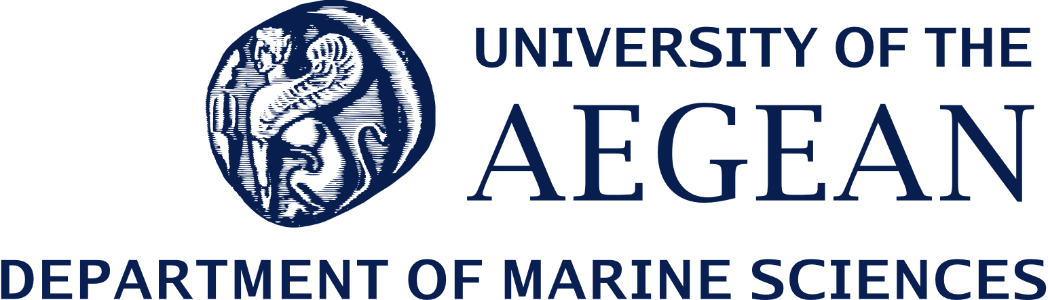
Application form for enrolment in the MSc Research in Marine Sciences

PERSONAL INFORMATION |  | Dear Sirs/Madams,  Please accept my application for a Master’s degree in Research in Marine Sciences in the Department of Marine Sciences at University of the Aegean.
Surname:
Name:
Place of Birth:
Date of Birth:
Nationality:
CONTACT DETAILS |  | APPLICATION CHECKLIST:
Correspondence address: |  | Scanned copy of BSc Diploma, or Certificate of Completion of Study
City: | Postal Code: | Scan of Diploma Supplement in which the individual courses and grades are indicated
Country: |  | Curriculum vitae stating the studies and any professional or research experience
Tel. no.: |  | Reprints of publications in international peer-reviewed journal (if any)
Mobile phone no.: |  | Documentation of any professional or research experience (if any)
E-mail address: |  | Proof of English language proficiency (at least B2 level) – not needed if English is the native language.
EDUCATIONAL BACKGROUND |  | Two recommendation letters (if any)
Bachelor’s degree: |  | Please give name/surname, title, affiliation and email of people writing the recommendation letters
University: |  | a)
Year completed: |  | b)
Final grade: |  | Scan of passport or national ID card
Other Degrees (BSc or MSc, stating University, grades and year) |  | any other information that would help the Examination/Selection Committee of Postgraduate Students
English language proficiency:  B2 level  C1 level  C2 level  Native Language:  Other Languages: |  | Signature  Date

