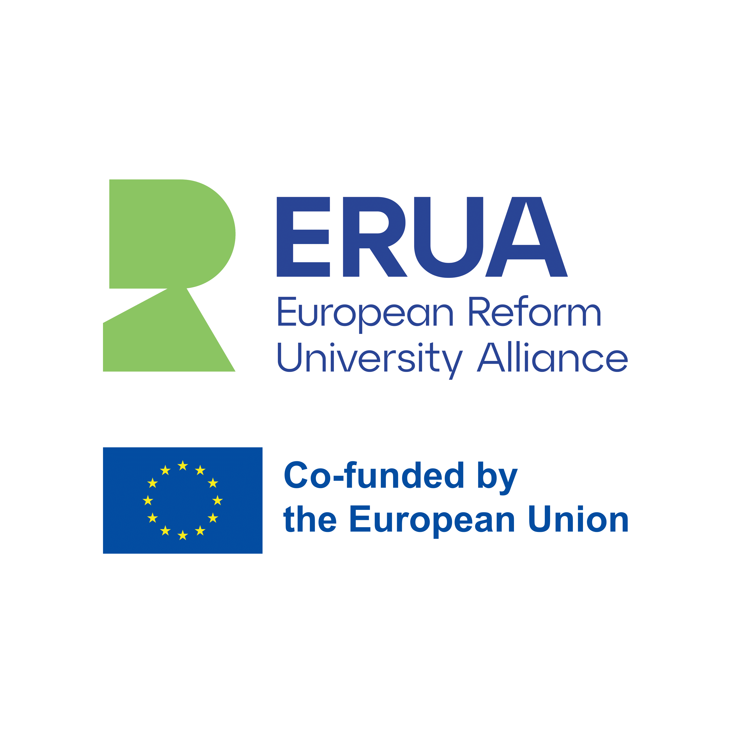

ERUA Travelling Seminar
“Children on the Move: Developmental Psychology, Inclusion and Air Travel in Europe”

Mytilene, Greece
25-27 May, 2026
Funded by the European Union. Views and opinions expressed are however those of the author(s) only and do not necessarily reflect those of the European Union or European Education and Culture Executive Agency (EACEA). Neither the European Union nor the granting authority can be held responsible for them.
Program Agenda

 | Geography Building |  Mytilene, Greece

 |  | Monday | May 25, 2026 | Τhe auditorium in the Geography Building, The building is located on the University of the Aegean campus hill.
17:30 – 20:00 |  | Lecture: Growing Up in Motion  An introduction to key developmental milestones and everyday needs of toddlers and preschoolers in the context of mobility and travel. The session links child development with inclusive and child-friendly air travel.  Workshop: Flying with Little Ones  A collaborative workshop focused on translating developmental psychology into practical recommendations for air travel with young neurotypical children. Participants will co-create evidence-based, child-sensitive travel guidelines.
 |  | Tuesday | May 26, 2026
10:00 -10:30  10:30 – 13:00 |  | Lecture: Attention in Transit  This lecture explores the developmental profile, needs, and challenges of preschool children with ADHD in travel-related environments. Particular attention will be given to regulation, sensory load, and routine disruption.  Workshop: ADHD-Friendly Flying  Participants will develop psychologically informed recommendations for more accessible and supportive air travel for preschoolers with ADHD. The workshop emphasizes inclusion, predictability, and practical adaptations.
 |  | Wednesday | May 27, 2026
10:00 -10:30  10:30 – 13:00 |  | Lecture: Autism and Air Travel  A short lecture on the developmental needs and common challenges experienced by preschool children with ASD in airport and flight settings. The session highlights inclusion, sensory sensitivity, and communication needs.  Workshop: Flying on the Spectrum  A hands-on workshop dedicated to designing evidence-based recommendations for air travel with preschool children with ASD. Participants will focus on accessibility, comfort, and inclusive travel practices.
(all hours are in EET)

Connect with us!
http://erua-eui.eu/

ERUA UAegean Office
email: erua-eui@aegean.gr | tel: +30 22510 36093 - 5
ERUA UAegean Group on Facebook



Connect via your own university’s credentials
SSID: eduroam

